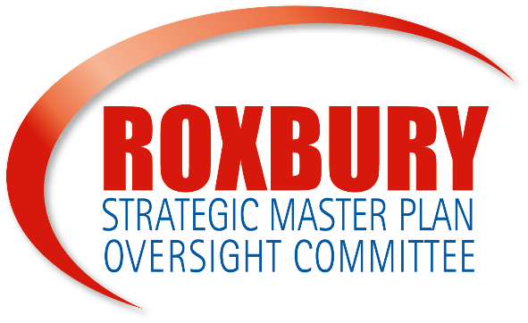

Roxbury Strategic Master Plan Oversight Committee
Public Meeting
September 14, 2020
6:00-7:45PM
Virtual Meeting | https://bit.ly/3lJPex6

Committee Overview of Role and & Responsibilities
The Roxbury Strategic Master Plan Oversight Committee (RSMPOC) was created in 2004 as a result of the Roxbury Strategic Master Plan (RSMP). The RSMPOC is broadly representative of the Roxbury neighborhood and is made up of Mayoral Appointees, nominated by elected officials, neighborhood associations, and community organizations. The RSMPOC oversees the implementation of the Roxbury Strategic Master Plan and PLAN: Nubian Square.
For more information on the RSMPOC, the RSMP, and previous meetings, please visit bit.ly/theRSMPOC or email rsmpoc@gmail.com.

Agenda
- RSMPOC Update – Welcome and Orientation
- Planning Update
- Development Update
- RSMPOC Comments and Questions
- Community Comments and Questions

Rules of engagement
- All public meetings will be recorded on the zoom platform. Recordings will be available on the RSMPOC website at bit.ly/theRSMPOC
- All public notices about meetings will be sent 3-4 weeks in advance. You can find announcements in the Bay State Banner, Boston Sun, and South End News.
- Meeting flow to allow more time for the public to ask questions and comment
- The public will have an opportunity to ask 6-8 questions, pending time restraints. Please limit your questions and comments and responses to 1-2 minutes so we can address as many questions as time allows.
- When speaking, please introduce yourselves indicating your name, if you represent an organization, and if you are a resident of Roxbury.

Community Engagement
- Join: Join the Roxbury Strategic Master Plan Oversight Committee, and/or a Project Review Committee (PRC)
- Engage: Attend public meetings. Ask questions. Invite neighbors, Roxbury civic groups and organizations, businesses, abutters or other community affiliates to public meetings.
- Take Action: Review and comment on projects, developments, and the planning initiative.

RSMPOC MEMEBERS

Catherine Hardaway
Roxbury Business Owner
Charlotte Nelson
Roxbury Resident
Dorothea Jones
Roxbury Resident
Frank Williams
Roxbury Resident
Frederick Fairfield
Dudley Square Main Streets
Lorraine Payne Wheeler
Roxbury Resident
Marisa Luse
Roxbury Resident
Nefertiti Lawrence
Roxbury Resident
Norman Stembridge
Roxbury Resident
Steven Godfrey
Quincy Geneva New Vision
Sue Sullivan
Newmarket Business Association
True-See Allah
Roxbury Resident
Valeda Britton
Boston University Medical Campus
EX-OFFICIO MEMBERS

State Senator
Sonia Chang-Diaz
State Representative
Liz Miranda
State Representative
Chynah Tyler
City Councilor President
Kim Janey

Next PLAN: Nubian Square Workshop
September 29
Virtual Meeting on Zoom
6pm-7:45pm

Please visit: bit.ly/PlanNubian
for more information

2020 RSMPOC PUBLIC MEETINGS –

January 6, 2020
Cancelled
February 3, 2020
Public Meeting
March 2, 2020
Public Meeting at Boston Water and Sewer
April 6, 2020
COVID-19 |Postponed
May 4, 2020
COVID-19 |Postponed
June 1, 2020
COVID-19 |Postponed
July 6, 2020
COVID-19 |Postponed
August 2020
--No Meeting--
September 14, 2020
Virtual Public Meeting
October 5, 2020
Virtual Public Meeting
November 2, 2020
Virtual Public Meeting
December 2020
TBD

---------------------------------------------------------------------------------------------------------------------------------------------------------
IMMEDIATE RESOURCES
If you or someone you know is currently facing displacement as a resident or business, please know in addition to BPDA staff the contacts and resources below are available for assistance:

Boston Home Center
617-635-4663 | bostonhomecenter.com

COVID-19 Resources
https://www.boston.gov/health-and-human-services/covid-19-help-residents

Office of Housing Stability and Emergency Assistance (OHS)
617-635-4200 | rentalhousing@boston.gov| Boston.gov/housing/office-housing-stability

Office of Workforce Development (OWD)
617-635-5283 | owd.boston.gov

Office of Small Business Development
SBCSUPPORT@BOSTON.GOV | boston.gov/departments/small-business-development

